RSE, Stay Safe, SPHE Policy

Introductory Statement:
Our school RSE, Stay Safe, SPHE Policy was reviewed in May 2021.

Rationale:
- To foster the personal development, health and well-being of all the children in our care.
- To help them to create and maintain positive and supportive relationships.
- To help them to become active and responsible members of society.
- To help them develop a framework of values, attitudes and skills which will enable pupils to make informed and responsible choices now and in the future.
- To benefit the teaching and learning experiences of the S.P.H.E Curriculum.
- To conform to the principles of learning outlined in the Primary School Curriculum.

Vision:
Shountrade N.S. values the uniqueness of all individuals within a caring school community. We recognise that SPHE is intrinsic in the learning and teaching that occurs both formally and informally in the school and in the classroom. Through our SPHE programme we wish to assist children in developing feelings of self-worth and self-confidence while encouraging their ability to relate to others in a positive way. The programme encourages children to be aware of their rights as individuals while at the same time accepting responsibility for their actions as members of the school and the wider community. Parents have the primary role in the Social, Personal and Health Education of their children so their involvement will be encouraged as much as possible.

Aims:
We endorse the aims and objectives of Social, Personal and Health Education curriculum for primary schools:
- to promote the personal development and well-being of the child.
- to foster, in the child, a sense of care and respect (for himself/herself) and others and an appreciation of the dignity of every human being.
- to promote the health of the child and provide a foundation for healthy living in all its aspects.
- to enable the child to make informed decisions and choices about the social, personal and health dimensions of life both now and in the future.
- to develop in the child a sense of social responsibility, a commitment to active and participative citizenship and an appreciation of the democratic way of life.
- to enable the child to respect human and cultural diversity and to appreciate and understand the interdependent nature of the world.

Objectives:
When due account is taken of intrinsic abilities and varying circumstances, the SPHE curriculum should enable the child to:
- be self-confident and have a positive sense of self-esteem.
- develop a sense of personal responsibility and come to understand his/her sexuality and the processes of growth, development and reproduction.
- develop and enhance the social skills of communication. co-operation and conflict resolution.
- create and maintain supportive relationships both now and in the future.
- develop an understanding of healthy living, an ability to implement healthy behaviour and a willingness to participate in activities that promote and sustain health.
- develop a sense of safety and ability to protect himself/herself from danger and abuse.
- make decisions, solve problems and take appropriate actions in various personal, social and health contexts.
- become aware of, and discerning about, the various influences on choices and decisions.
- begin to identify, review and evaluate the values and attitudes that are held by individuals and society and to recognise that these affect thoughts and actions.
- respect the environment and develop a sense of responsibility for its long-term care.
- develop some of the skills and abilities necessary for participating fully in groups and in society.
- become aware of some of the individual and community rights and responsibilities that come from living in a democracy.
- begin to understand the concepts of personal, local, national, european and global identity.
- appreciate and respect the diversity that exists in society and the positive contributions of various cultural, religious and social groups.
- promote the values of a just and caring society in an age-appropriate manner and understand the importance of seeking truth and peace.

Curriculum Planning –Strands and strand units
The three main strands of the SPHE curriculum are:
Myself
Myself & others
Myself & the Wider World
The strand units are consistent throughout all the class levels, reflective of the spiral nature of the curriculum.

The SPHE Curriculum Documents will inform the planning of content, approaches and methodologies employed by individual teachers. Coverage of the strand units each year will be as outlined in this plan. Each teacher will clearly detail the learning intentions of lessons in short term plans. The recording in the Cúntais Mhíosúla of work done will help to monitor progress and assist in future planning.

Strand: Myself
Strand Unit
Self Identity  - Personal Preferences  - Self awareness  - Self reliance  - Making decisions | Children are encouraged to see themselves as unique individuals, with differing abilities, strengths and limitations, who are loved and cared for and who have an important contribution to make in life.  As the children progress through the school, more emphasis is placed on helping them to deal with the various factors that influence their self-esteem and self-concept, such as the role of peers, the role of families, personal successes and failures, media images, and the affirmation of others.
Taking Care of my Body  - Nutrition | The strand unit focuses on promoting health by exploring:  - the need for regular exercise  - food and nutrition and the significance of healthy eating habits  - the use and misuse of various substances  - the transmission of infection and disease  As physical growth and development are explored, children learn the appropriate anatomical terms for the private parts of both the male and female body. Acquiring this vocabulary at an early age provides the foundation for later learning on puberty and reproduction and can help children to speak about all parts of their bodies in a respectful and dignified way
Growing and Changing  - Growth and change  - Feelings and Emotions | Children begin to understand that the rate at which each person grows is unique and that growth is characterised by a combination of social, emotional, intellectual, spiritual and physical factors.  It is also essential that children have an understanding of puberty and human reproduction before they leave primary school.  Children need to learn to recognise and manage their own feelings. Opportunities are provided for them in this strand unit to name, express and deal with these feelings. The emphasis is placed on exploring the whole spectrum of feelings without labelling them as either positive or negative. Understanding one’s own feelings increases self understanding and allows for greater awareness of one’s own moods, intentions and motivations.
Safety and Protection  - Safety issues  - Personal safety | Children are made aware of potentially dangerous situations and are given the opportunity to explore strategies that can be used to help protect themselves and others.  Children also explore the concept of risk. It is important that they develop a balanced perspective on risk taking by assessing situations and examining consequences. Children are encouraged to recognise a potentially serious situation and to know how to take appropriate action  All the content objectives, at all class levels under ‘personal safety’ which is part of the safety and protection strand unit can be met by teaching the Stay Safe programme.
Decision Making (3rd -6th) | Being able to make informed decisions and choices is inherent in SPHE. In this strand unit, children can identify and recognise the kinds of decisions they can and cannot make and the factors that may influence their choices. They will learn how to:  - exercise judgement  - weigh up different possibilities  - examine the steps and choices that guide them towards considered decision making  - begin to understand their own rights, the rights of others and associated responsibilities  - explore the various factors that influence decision making  - reflect on actions taken

Strand -Myself and Others
Myself and My Family | Children learn to value family life and appreciate their own families, beliefs and traditions through  - Identifying what constitutes a family  - emphasising the fact that family units and structures may not all be the same  - explore the kinds of things that families can do together and how they can care for, love and support each other  - identifying the different roles within families, understanding that these roles may vary and recognising that each individual makes a contribution to family life  - beginning to look at the behaviour that promotes harmony in families and becoming aware of the types of changes that could affect family life e.g the birth of a new baby, moving house or school, separation, illness, violence or unemployment  - examining the concept of belonging to a family and exploring how family life can alter as children move into adolescence and adulthood  - exploring the reality of the images of family life and lifestyles presented in the media
My friends and other People | This strand unit begins with the child’s experience of immediate friends and broadens out to include other people the meaning and significance of friendship, what can threaten it and how it can be supported  - aspects of genuine friendship such as listening, trust, honesty, laughter, empathy and the importance of spending time together  - making and changing friends as part of growing up  - the ways in which individual actions and behaviour affect others  - treating others with dignity and respect  In the senior classes the programme facilitates the exploration of both same-sex and boy-girl friendships. Emphasis is also placed on examining the positive and negative role of peers and on helping children to cope with pressure and persuasive influences. In exploring gender equity children are given the opportunity to reflect on their own attitudes and values and to discover ways of counteracting stereotypical images.
Relating to others | This focuses on the development of a range of communication and interpersonal skills.  Children are encouraged to  - listen effectively  - talk, discuss, question and practice various non-verbal forms of communication  - learn about different types of communication and explore their effectiveness and appropriate use  - give and receive compliments, affirmation and constructive criticism  - empathise with others and explore issues from a variety of perspectives  - learn how to deal with conflict by practising different techniques that focus on identifying the problem and exploring possible solutions: for example, they can learn how to compromise, to apologise, to receive an apology and to forgive.  - Children can come to an understanding of what bullying is, the type of behaviour that constitutes bullying and the role of various people in bullying situations. They are taught that there are certain steps to take if they are being bullied or if they see someone else being bullied.

Strand: Myself and the Wider World
Developing Citizenship | This strand unit begins by focusing on the school or class as a community in microcosm. By experiencing community in such a practical way, children learn what belonging and participation really mean.  In a school that values caring and shared responsibility, children can learn to:  - share and cooperate  - set realistic goals and targets for themselves and others  - develop leadership and administrative qualities  - celebrate difference  - be part of something that goes beyond personal interest and recognise that they can make a valuable contribution to society  - The concept of democracy becomes real and meaningful for children as they are given the opportunity to: voice individual opinions, undertake a variety of responsibilities, reach group decisions by consensus, listen to different points of view, work both as an individual and as a member of a group, be involved in school decision making  - children explore the diversity of the world in which they live. They are encouraged to learn about their own traditions and culture and are given opportunities to compare and contrast those with other ethnic or cultural groups in society. They explore and examine how discrimination can occur in school, in the local community and in their own country.  - exploring aspects of local, national, European and wider communities can help children develop a sense of the interdependent nature of the world.
Media Education | Media education encourages children to examine the media in a critical way and to explore how they can influence behaviour and opinion.  Children are given an opportunity to:  - become familiar with different media, explore how prejudice and partiality can distort information, explore some of the techniques used in the media, examine how these techniques are used in promoting particular ideas or in selling particular products, look at the media in a critical way by asking questions, exploring perspectives and examining bias, begin to investigate advertising and marketing strategies and practice using some of these approaches for themselves, become discerning about the messages they receive from different media sources , examine how families and relationships are portrayed in the media, how conflicts are resolved and how intimacy and sexuality are represented, examine the effects of advertising on various aspects of life, e.g. on purchasing, dietary habits, health behaviour and lifestyle.  - to explore the range of information available to them through information and communication technologies. They are encouraged to make the technology work for them and become discerning and judicious media users.

SPHE is planned so that children receive a comprehensive programme over a two year cycle. This ensures that the strand units not covered in Year One are included in the programme of work for the following year. In some cases it may be necessary to revise specific objectives from the previous year. The plan will form the basis for teachers’ long and short term planning, and will inform new or temporary teachers of the approaches and methodologies used in our school.

Content for SPHE over 2 years
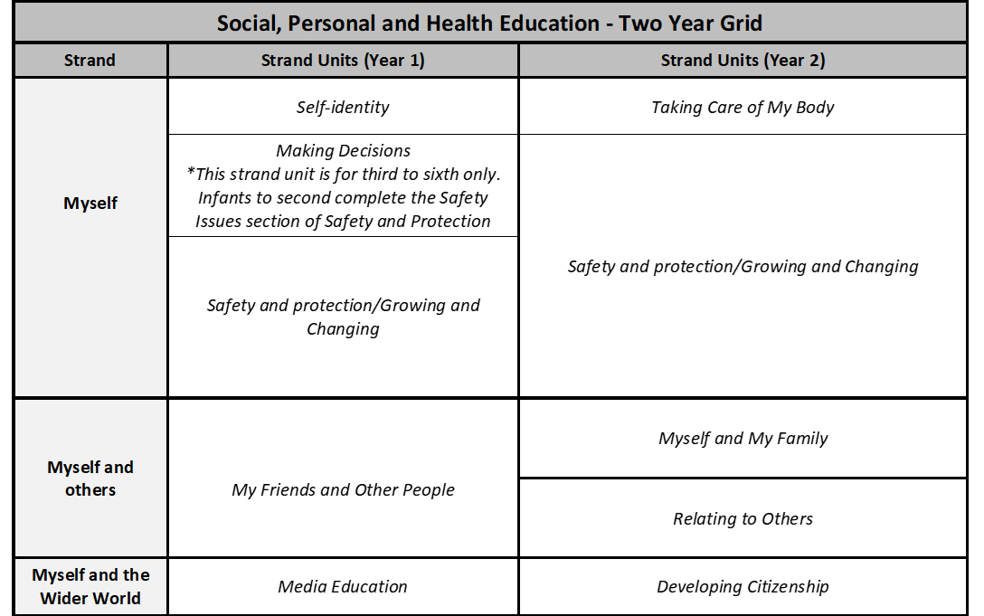
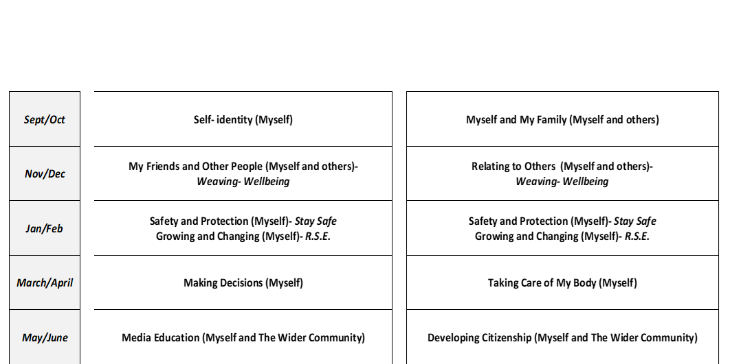

See “Making the Links” appendix 1 for full overview of content.

RSE /Stay Safe
The RSE and Stay Safe programme is implemented in every class every year.
- The sensitive issues of RSE will be taught from Infants to 6th class.
- They will ideally be taught by the teaching staff. Occasionally it may be deemed necessary for an outside speaker to address the “sexually sensitive issues” i.e. puberty, reproductive system, conception, birth and sexual intercourse on the 5th and/or 6th Class curriculum.
- All resources used will be in keeping with the ethos of the school and this policy.
- Sensitive issues classes are generally taught during the third term.
- In a multi class situation, the younger class will be withdrawn when topics being taught are not age-appropriate
- When an outside speaker is used, the SPHE coordinator/principal will make them fully aware of school policy. Parents/guardians will be notified of the name of this speaker in advance of the lesson. The class teacher will remain with the class during the lesson.

Organisational Matters
- Prior to the teaching of lessons involving “sensitive issues”, parents will be informed by letter with an accompanying outline of the lesson

- It is a parents/guardians right to withdraw a pupil from these lessons. If parents are concerned about the more sensitive aspects of the RSE or Stay Safe programmes, they are welcome to visit the school to examine the content of the programmes and discuss their concerns with the principal. Following this meeting if parents wish to have their child/ren withdrawn when sensitive issues are being taught, they are requested to submit this in writing to the Principal. Parents will be expected to make their wishes know each year to the new class teacher.
- If parents/guardians request the withdrawal of a child from RSE lessons, efforts will be made by the school, using the resources it has, to accommodate these children by providing supervision within another classroom.
- With regard to matters of a confidential nature, the school cannot take any responsibility for what is discussed in the yard or classroom. Should a child who is withdrawn from the sexually sensitive classes receive inappropriate information from others outside of these classes, it will be the responsibility of the parent/guardian to address the issues.
- Any teacher has the right to opt-out from teaching the sexually sensitive issues in RSE. It is responsibility of Board of Management to ensure that the curriculum will be delivered to the children, by another teacher, or an outside speaker.
- Parents are welcome to view the curriculum and may speak to the class teacher if they have any concerns.
Dealing with Questions
It is natural that children should wish to ask questions in the area or RSE. However, this area is treated somewhat differently from other subjects due to its sensitive nature.
All questions answered will reflect the parameters of the curriculum. Certain topics will not be discussed i.e. abortion, masturbation, homosexuality, contraception. Questions to the teacher may be written or oral within the group setting and answered within the boundaries of the curriculum and school policy. If any questions asked by the children are judged to be inappropriate, the teacher will refer the child to their parents, or state that this information may be available at a later stage of the curriculum. The school cannot guarantee confidentiality if a child asks a question of a personal nature or discloses personal information.

At all times the child’s and teacher’s right to privacy will be maintained.

Stay Safe programme content:
The lessons cover the following areas:
- Feeling Safe and Unsafe
- Friendship and Bullying
- Touches
- Secrets and Telling
- Strangers

Children participating in this programme will learn:
- To distinguish between safe and unsafe feelings
- What to do if lost
- What to do if the phone or doorbell rings when they are alone in the house
- The importance of friends in children’s lives
- What to do if bullied
- Stay Safe Rules: Say No/ Get Away/ Tell
- Why not to bully others
- Appreciating normal, appropriate touches
- That unsafe touches should never be kept secret
- How to respond to inappropriate touches (Stay Safe Rules)
- Good and bad secrets
- That some secrets should not be kept
- Who and how to tell if in trouble
- About strangers and safety strategies

RSE - Sensitive Areas
Junior Infants
New Life – mention of baby in the womb.
Senior Infants
My Body – specific names for male and female sex organs – vagina, penis, womb.
First Class
New Life – New baby. Baby joined to mother by umbilical cord – mention breast feeding.
Second Class
Birth of baby through vagina. Mention umbilical cord and breast feeding.
Third Class
As for second class, but in more detail.
Fourth Class
Language around baby’s development in womb, i.e., fertilised egg, cord. Pictures of foetuses (in RSE manual) to be used.
Fifth and Sixth Classes
Menstruation in the context of hygiene and growth from a girl to a woman.
Boys and girls development – puberty.
How does new life begin? ( 6th class only)
Biological facts as follows: ( 6th class only)
- What journey does the egg make?
- What journey does the sperm make?
- Where do they meet?
- What happens when they meet?

Contexts for SPHE
Positive School Climate

  - Each teacher develops a Positive Classroom Climate where children are listened to, feel safe to talk, and which offers many opportunities for the development of the child.
  - Every child and staff member is regarded as unique and is valued and treated with respect.
  - Good relationships between students, parents, teachers and management founded on respect create a positive school environment where the SPHE curriculum can be fully implemented.

Discrete Time
SPHE may be timetabled for 30 mins per week, one hour per fortnight or blocks of 1-2 hours per month where feasible or appropriate. Children who are withdrawn for supplementary teaching must be included for as much as the SPHE programme as possible. No child is withdrawn during the Stay Safe programme, which is taught from Junior Infants to 6th class each year.
In dealing with sensitive issues during RSE, a guest speaker may be invited. In recent years, the class teacher has given lessons to 6th class in this area.

Integration
We recognise that SPHE spans the entire curriculum. Class teachers will endeavour to integrate SPHE themes throughout the curriculum. Many aspects of SPHE can be dealt with in the context of English, gaeilge, PE, SESE, religion and drama.
Approaches and Methodologies
Active learning is a key principle of the overall curriculum and is the principal learning and teaching approach used for teaching SPHE.
The following active learning strategies will be promoted in the school
- Drama activities
- Co-operative games
- Pictures, photographs and visual images
- Discussion: in pairs, small groups, with whole class
- Written activities: surveys, questionnaires, lists, check-lists, projects, worksheets
- Media Studies
- Information and communication technologies
- Looking at children’s work: portfolios, projects
- Use of external speakers/visitors e.g nurse, dentist, doctor, garda etc
Assessment
Children’s progress in SPHE is assessed mainly through
- Teacher Observation
- Teacher Designed Checklists
- Work samples, portfolios and projects
- Self- Assessment by children

Teachers will share information with each other, with parents, with children, with other professionals either informally, or formally through a written report at the end of the school year.

Children with Different Needs
The SPHE programme aims to meet the needs of all children in the school. This will be achieved by varying the pace, content and methodologies to ensure learning for all pupils. The requirements of children with special needs will be taken into consideration when planning class lessons and related activities. Members of the SET team will positively support the work of the class teacher.

Equality of Participation and Access
We view the SPHE programme as playing a key role in ensuring equality of opportunities for all children to participate in classes/activities. The programme at each class level will be flexible so that the learning requirements of all children may be addressed. We provide an equal educational experience for both boys and girls as we recognise that stereotyped expectations of gender roles can inhibit children’s educational achievements. Children with special needs will be included in all activities. Diversity within our school community will be recognised by valuing and promoting the needs, interests, skills and talents of children with special needs.

Homework
Homework will take the format of handouts and materials from various programmes, such as Stay Safe, Walk Tall, RSE, etc. The purpose of such homework is to allow for discussion with parents to ensure a balanced approach to topics dealt with.
Policies
SPHE links with school policies/programmes: Substance Use, RSE, Child Protection, Enrolment, Attendance, Code of Behaviour, Anti-Bullying, Health and Safety, Healthy Eating, Homework. Teachers are expected to be familiar with these policies and ensure that the school’s agreed policy is followed when addressing these issues.
Resources
- Curriculum Documents for SPHE
- Bí Folláin

- Weaving Wellbeing Programme
- Walk Tall, Programme for the Prevention of Substance Misuse
- Stay Safe Programme, Health Promotion Unit, Dublin
- Grow in Love Religion Programme
- RSE Programme
- Guest Speakers - On occasions it may be appropriate to invite guest speakers to visit the school. Speakers with expertise in a given topic area will be chosen following research and investigation by teachers (including recommendations from other schools).
Staff Development
- An atmosphere of open communication exists between all staff members and skills, expertise and experience in teaching SPHE are shared.
- Teachers are informed of SPHE-related courses available, and are encouraged to attend. Information acquired at these courses is made available to other staff members, e.g. photocopying worksheets, access to SPHE packages in staff room, etc.
- Time is allocated at staff meetings for the discussion of all subjects, including SPHE.
- Resource teachers and Learning Support teachers have the role of supporting the class teacher in the teaching of the SPHE curriculum.
Parental Involvement
The parents have the primary role in the SPHE of their children and as such the school supports them in this role. As stated parents/guardians will be given the option of withdrawing their child from a particular lesson if they so wish.
Opportunities for involvement are provided and include:
- Support of Stay Safe programme
- Schools healthy lunches
- Homework
- Green Schools/Tidy Towns
- Guest speakers for parents regarding SPHE issues
- Christmas Concert / shows
- Parent / teacher meetings
- The Parents’ Council may on occasion arrange for speakers/meetings to help them in the task of communicating with their children on aspects of their development.
- All resources are available for parents/guardians to view if they so request prior to the delivery of the lesson. Parents/Guardians may access copies of the policy from the school office, or school website.
Community Links
We value the contribution which members of the local community can make towards furthering the aims and objectives of SPHE in our school. The community guard, medical persons, people of other cultures, members of local community groups and the media have much to offer in supporting the SPHE programme.

Success Criteria
Success achieved will depend on thorough preparation of teacher’s work and consistently followed procedures outlined in the plan. Indications of success will come through positive feedback from the members of the school community- teachers, parents, pupils, local community and from the second level schools attended by our past pupils. However, in many situations, success can only be measured by the way children mature and live their lives.

Implementation
This plan has been formulated by the staff of our school. It will be supported, developed and implemented by teaching and non-teaching staff members. The school principal will co-ordinate its progression.

Review
This policy will be reviewed accordingly.

Ratification/review
This policy has been ratified/reviewed by the Board of Management on .

Chairperson BOM__________________________________

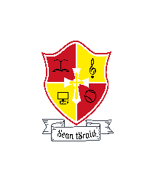
Shountrade National School

DATE:

Dear Parents/Guardians,

We are planning to teach a personal safety education programme called Stay Safe over the next number weeks. The aim of the Stay Safe programme is to teach children personal safety skills so they can look after themselves in situations which could be upsetting or dangerous. It deals initially with common situations which most children will experience at some stage or other, e.g., getting lost or being bullied. The programme also teaches children the safety skills necessary to protect themselves from physical or sexual abuse and emphasises the importance of telling a trusted adult about any problems they have.

The Stay safe programme is part of the Social, Personal and Health Education curriculum which all primary schools are required to implement. You can familiarise yourself with the content of the Stay Safe lessons at www.staysafe.ie/teachers/resources.htm.

Thank you for your co-operation,

___________________________
Class Teacher

Shountrade National School

DATE:

Dear Parents/Guardians,

I wish to inform you that I will be exploring a series of RSE (Relationship and Sexuality Education) lessons with 5th class in May. Over the course of these lessons, I will be covering the following topics:

- Introducing Puberty
- Why does puberty happen?
- What happens to girls?
- What happens to boys?
- Enjoying growing up

I will be using the HSE’s publication ‘Busy Bodies’ and DVD as my primary resource. I have attached a PDF version of the Booklet to this Email for you should you wish to discuss these topics with your child.

If you do not wish for your child to participate in these lessons, please let me know.

Kind regards,

Shountrade National School

DATE:

Dear Parents/Guardians,

I wish to inform you that I will be exploring a series of RSE (Relationship and Sexuality Education) lessons with 6th class in May. Over the course of these lessons, I will be covering the following topics:

- Introducing Puberty
- Why does puberty happen?
- What happens to girls?
- What happens to boys?
- Making babies
- Enjoying growing up

I will be using the HSE’s publication ‘Busy Bodies’ and DVD as my primary resource. I have attached a PDF version of the Booklet to this Email for you should you wish to discuss these topics with your child.

If you do not wish for your child to participate in these lessons, please let me know.

Kind regards,

